CSCE 5290: NATURAL LANGUAGE PROCESSING
Project Increment – 1

Table of Content

- PROJECT DESCRIPTION

- PROJECT TITLE AND TEAM MEMBERS
- GOALS AND OBJECTIVES
- MOTIVATION
- SIGNIFICANCE
- OBJECTIVES
- FEATURES

- REQUIREMENTS AND TOOLS

- DATASET

- PROJECT MANAGEMENT
- WORK COMPLETED
- WORK NEEDS TO BE COMPLETED

- REFERENCES

A) PROJECT DESCRIPTION:
1) Project title and Team members:
Project name: SENTIMENT ANALYSIS ON LIVE TWEETS
Team members:
- CHAITANYA KUMAR POTHURAJU – 11526614
- DINESH CHANDRA SAYANA –
- KIRANKUMAR DANTHALA –

2) Goals and Objectives:
- Motivation:
As text data is enormously increasing in the modern era and with the advent of social media, data is increasing with rapid pace this data contains public feelings, Opinions, review about products and many more emotions. So, we wanted to processes this text data and find out the sentiments from the text. This application also helps business to make decisions. which will help us learning the machine learning concepts as well as NLP.
- Significance:
Sentiment analysis is becoming vital tool for modern business in order to understand public emotions and there by taking business decision based on sentiment analysis. It also helps in finding brand reputation, product success rate, product dissatisfaction in the public.
- Objective:
The main objective of our project is to calculate the sentiments of tweet. We are considering for extraction of the following sentiments which are HAPPINESS, SAD, ANGRY, NEUTRAL.
- Features:
Our sentiment analysis model is based on LSTM and also tweets were sorted according to the geographical locations, our tool allows for easy deployment without disrupting the workflow. Aspect based sentiment analysis is also one of the features of our tool, this implies that for each written content, you may acquire various sentiment scores ranging from positive to negative. It's also incredibly configurable, so it'll be tailored just to your company's needs.
B) REQUIREMENTS AND TOOLS:
Numpy
Scikit-learn
Scipy
Nltk
Keras
TensorFlow for Logistic Regression, RNN and CNN
Xgboost

C) DATASET:

https://www.kaggle.com/kazanova/sentiment140

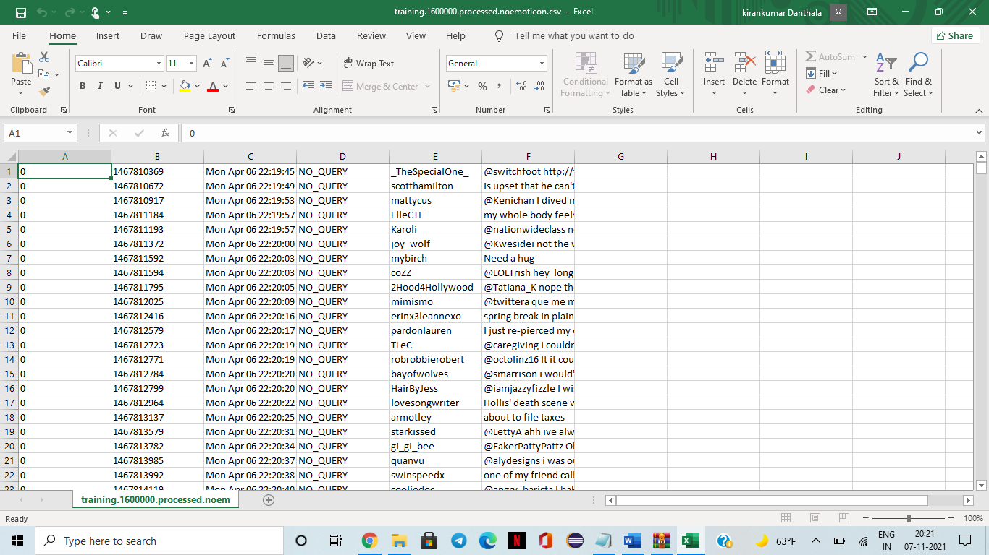

D) PROJECT MANAGEMENT:
- WORK COMPLETED:
Description:
In this step we have successfully created a developer account for the twitter user handle. The data set has been collected and, we also fetched the live tweets.

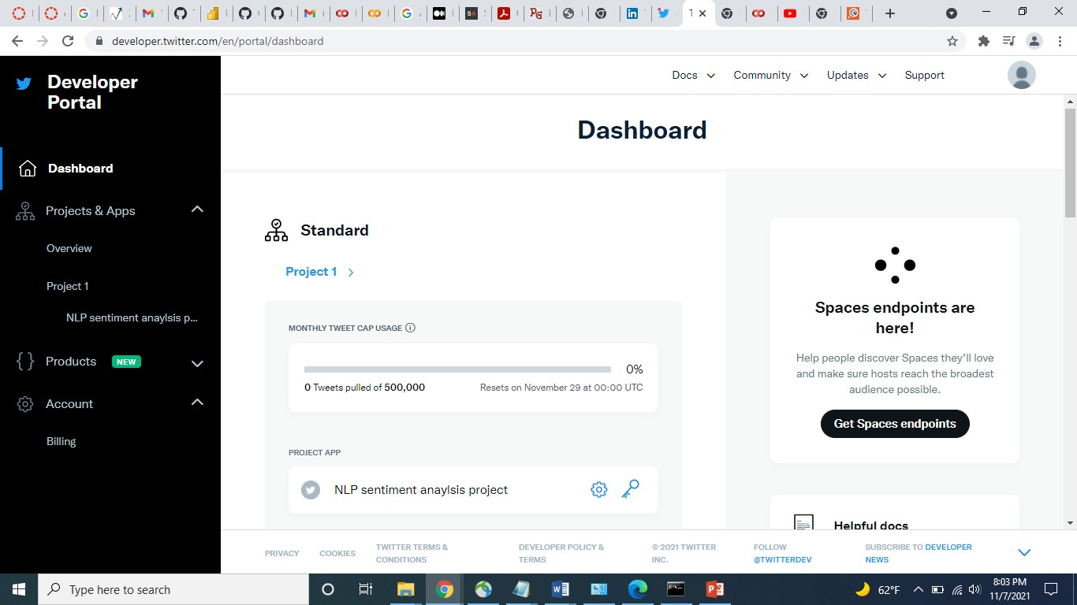
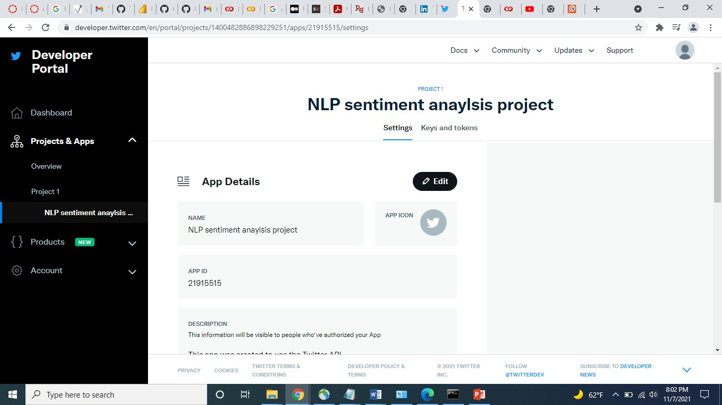

- WORK NEEDS TO BE COMPLETED:
Description:
Most of the execution part which contains training, building and modifying data needs to be done and will do testing on the randomly generated tweets dataset.
E) REFERENCE:
- http://jestec.taylors.edu.my/Vol%2015%20issue%205%20October%202020/15_5_27.pdf

- https://d1wqtxts1xzle7.cloudfront.net/56761095/1524474367_23-04-2018-with-cover-page-v2.pdf?Expires=1636342284&Signature=Kpn3XY0c-j1CFN8USFqwODs5ImgQOiu7uqXRYlMoH0eM1dZ-y45zEg-3dOI-0mJAeRSmK3XbsStlxFTqTBthkWCfoor8hUQVpKXoX35LYPrWOZyCHC5ajBeadGr1RyMTxRUeBB4zCjG6Ng3lofiMKeLlPJ9vGQx3FY5W~xXoUGvho0W5jfKckNwG6nVfs4QxW-mOU~MUDd01yzGP5r06R8lWWEwgwhINOkrM-xvKAfSoV1~8y-9DnGRMGFGuX6wrf06qw7MWiuFXc1pLpjZWiNLB-iGoy23VpIqMQAi39TNZfeNZMadlfuXP4yZyLiXPRX-c4GSTJnPMMthlL1oDKg__&Key-Pair-Id=APKAJLOHF5GGSLRBV4ZA

